***OS EXP 4:Schedulling Algorithms***

***1)First Come First Serve Without Arrival***

#include<stdio.h>

///Non-Arrival First Come First Serve

///Adnan Ismail Shah Muzavor

#include<stdlib.h>

/// Sorting key will help in sorting

/// when we want to sort values based on some

/// some other aspect

typedef struct array

{

int b_time; ///burst_time

int s_key; ///sorting key eg priority

} Prc;

///To find average

float avg(int *arr,int n)

{

float avg=0.0;

int i=0;

for(i=0; i<n; i++) avg+=(float)arr[i];

return (avg/(float)n);

}

///To display the result

void display(int *wt,int *tt,int n)

{

int i;

printf("Process\t\tWaiting time\t\tTurnaround time\n");

for(i=0; i<n; i++)

{

printf(" p%d \t\t%d\t\t\t%d\n",i+1,wt[i],tt[i]);

}

printf(" avg \t\t%.2f\t\t\t%.2f\n",avg(wt,n),avg(tt,n));

}

void FCFS(Prc p1[],int n)

{

int*wt=(int*)malloc(sizeof(int)*n);

int*tt=(int*)malloc(sizeof(int)*n);

int*gt=(int*)malloc(sizeof(int)*n);

int sum=0,i,gt_itr=0;

for(i=0;i<n;i++) gt[i]=0;

wt[0]=0; //Initially waiting time is zero for first process in p1

gt[gt_itr]=0;

for( i=0; i<n; i++)

{

///Calculate waiting time

if(i>0)

{

/// for i=0, we already know waiting time is zero

/// otherwise it is burst time of prev process

sum=sum+p1[i-1].b_time; /// Burst time of ith process

wt[i]=sum;

}

///Calculate turnround time

tt[i]=p1[i].b_time+sum;

gt[gt_itr]=sum;

gt_itr++;

}

gt[gt_itr]=sum+p1[n-1].b_time;

gt_itr++;

display(wt,tt,n);

ganttchart(p1,gt,n,gt_itr);

}

void ganttchart(Prc *p,int*gt,int n,int n2){

int i;

printf("\nGantt chart is: \n");

for(i=0;i<n;i++){

printf("------");

}

printf("\n");

for(i=0;i<n;i++){

printf(" p%d |",i+1);

}

printf("\n");

for(i=0;i<n;i++){

printf("------");

}

printf("\n");

for(i=0; i<n2; i++)

{

printf("%d ",gt[i]);

}

}

int main()

{

int n,i;

printf("Enter the number of processes: ");

scanf("%d",&n);

Prc *p1=(Prc*)malloc(sizeof(Prc)*n);

printf("\nEnter the burst time for: \n");

for(i=0; i<n; i++)

{

printf("Process %d: ",i+1);

scanf("%d",&p1[i].b_time);

p1[i].s_key=-1;

//printf("\n");

}

printf("Process\t\tBurst time\n");

for(i=0; i<n; i++)

{

printf(" p%d \t\t%d\n",i+1,p1[i].b_time);

}

printf("\nFirst Come First Serve:\n");

FCFS(p1,n);

return 0;

}

**OUTPUT:**

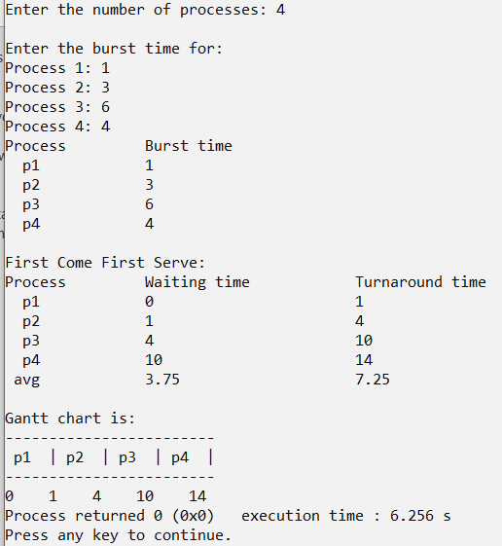

***2)Shortest Job First Without Arrival***

#include<stdio.h>

///Non-Arrival Shortest job first

///Adnan Ismail Shah Muzavor

#include<stdlib.h>

/// Sorting key will help in sorting

/// when we want to sort values based on some

/// some other aspect

typedef struct array

{

int b_time; ///burst_time

int s_key; ///sorting key eg priority

} Prc;

///In THIS ALGO WE NEED TO SORT NUMBERS

///I.E BURST TIME FROM SMALL TO LARGE SO THAT

///SHORTST PROCESS EXECUTES FIRST

void merge(int l,int m,int h,Prc p1[],int order[])

{

///id s_key is one use sort key else sort directly

int temp[h-l+1];

int new_order[h-l+1];

int i=l,j=m+1,k=0;

while(i<=m && j<=h)

{

///if sorting based on B_time directly s_key=0

if(p1[i].b_time<=p1[j].b_time)

{

temp[k]=p1[i].b_time;

new_order[k]=order[i];

i++;

k++;

}

else

{

temp[k]=p1[j].b_time;

new_order[k]=order[j];

j++;

k++;

}

}

///Add remaining elemnts

while(i<=m)

{

temp[k]=p1[i].b_time;

new_order[k]=order[i];

k++;

i++;

}

///Add remaining elemnts

while(j<=h)

{

temp[k]=p1[j].b_time;

new_order[k]=order[j];

k++;

j++;

}

///Modify original array

i=l,k=0;

while(i<=h)

{

p1[i].b_time=temp[k];

order[i]=new_order[k];

i++;

k++;

}

}

void mergesort(int i,int j,Prc p1[],int order[])

{

if(i<j)

{

int m=(i+j)/2;

mergesort(i,m,p1,order);

mergesort(m+1,j,p1,order);

merge(i,m,j,p1,order);

}

}

///To find average

float avg(int *arr,int n)

{

float avg=0.0;

int i=0;

for(i=0; i<n; i++) avg+=(float)arr[i];

return (avg/(float)n);

}

///To display the result

void display(int *order,int *wt,int *tt,int n)

{

int i;

printf("Process\t\tWaiting time\t\tTurnaround time\n");

for(i=0; i<n; i++)

{

printf(" p%d \t\t%d\t\t\t%d\n",order[i]+1,wt[i],tt[i]);

}

printf(" avg \t\t%.2f\t\t\t%.2f\n",avg(wt,n),avg(tt,n));

}

void SJF(Prc p1[],int *order,int n)

{

int*wt=(int*)malloc(sizeof(int)*n);

int*tt=(int*)malloc(sizeof(int)*n);

int*gt=(int*)malloc(sizeof(int)*n);

int sum=0,i,gt_itr=0;

for(i=0;i<n;i++) gt[i]=0;

wt[0]=0; //Initially waiting time is zero for first process in p1

gt[gt_itr]=0;

for( i=0; i<n; i++)

{

///Calculate waiting time

if(i>0)

{

/// for i=0, we already know waiting time is zero

/// otherwise it is burst time of prev process

sum=sum+p1[i-1].b_time; /// Burst time of ith process

wt[i]=sum;

}

///Calculate turnround time

tt[i]=p1[i].b_time+sum;

gt[gt_itr]=sum;

gt_itr++;

}

gt[gt_itr]=sum+p1[n-1].b_time;

gt_itr++;

display(order,wt,tt,n);

ganttchart(p1,order,gt,n,gt_itr);

}

void ganttchart(Prc *p,int*order,int*gt,int n,int n2){

int i;

printf("\nGantt chart is: \n");

for(i=0;i<n;i++){

printf("-----");

}

printf("\n");

for(i=0;i<n;i++){

printf(" p%d |",order[i]+1);

}

printf("\n");

for(i=0;i<n;i++){

printf("-----");

}

printf("\n");

for(i=0; i<n2; i++)

{

printf("%d ",gt[i]);

}

}

int main()

{

int n,i;

printf("Enter the number of processes: ");

scanf("%d",&n);

Prc *p1=(Prc*)malloc(sizeof(Prc)*n); ///Storing values of the array

int *pr_order=(int*)malloc(sizeof(int)*n); ///For storing process order

for(i=0;i<n;i++) pr_order[i]=i;

printf("\nEnter the burst time for: \n");

for(i=0; i<n; i++)

{

printf("Process %d: ",i+1);

scanf("%d",&p1[i].b_time);

p1[i].s_key=-1;

}

printf("Process\t\tBurst time\n");

for(i=0; i<n; i++)

{

printf(" p%d \t\t%d\n",pr_order[i]+1,p1[i].b_time);

}

mergesort(0,n-1,p1,pr_order); ///Sort based on burst time only

printf("\nAfter Shortest Job First Schedulling\n");

SJF(p1,pr_order,n);

return 0;

}

**Output:**

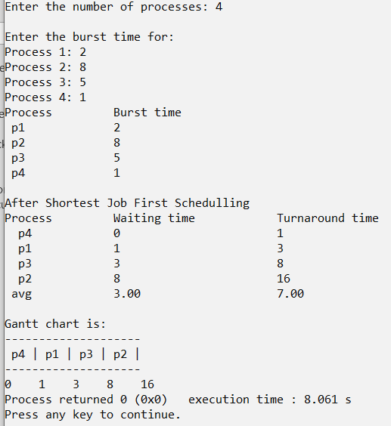

***3)Non Preemtive Priority Without Arrival***

#include<stdio.h>

///Non-Arrival Non-preemtive priority

///Adnan Ismail Shah Muzavor

#include<stdlib.h>

///Sorting key will help in sorting

/// when we want to sort values based on some

/// some other aspect

typedef struct array

{

int b_time; ///burst_time

int s_key; ///sorting key i.e priority

} Prc;

///In THIS ALGO WE NEED TO SORT NUMBERS

///I.E BURST TIME FROM SMALL TO LARGE SO THAT

///SHORTST PROCESS EXECUTES FIRST

void merge(int l,int m,int h,Prc p1[],int order[])

{

///id s_key is one use sort key else sort directly

int temp[h-l+1];

int new_order[h-l+1];

int prty[h-l+1];

int i=l,j=m+1,k=0;

while(i<=m && j<=h)

{

if(p1[i].s_key<=p1[j].s_key)

{

temp[k]=p1[i].b_time;

new_order[k]=order[i];

prty[k]=p1[i].s_key;

i++;

k++;

}

else

{

temp[k]=p1[j].b_time;

prty[k]=p1[j].s_key;

new_order[k]=order[j];

j++;

k++;

}

}

///Add remaining elemnts

while(i<=m)

{

temp[k]=p1[i].b_time;

prty[k]=p1[i].s_key;

new_order[k]=order[i];

k++;

i++;

}

///Add remaining elemnts

while(j<=h)

{

temp[k]=p1[j].b_time;

prty[k]=p1[j].s_key;

new_order[k]=order[j];

k++;

j++;

}

///Modify original array

i=l,k=0;

while(i<=h)

{

p1[i].b_time=temp[k];

order[i]=new_order[k];

p1[i].s_key=prty[k];

i++;

k++;

}

}

void mergesort(int i,int j,Prc p1[],int order[])

{

if(i<j)

{

int m=(i+j)/2;

mergesort(i,m,p1,order);

mergesort(m+1,j,p1,order);

merge(i,m,j,p1,order);

}

}

///To find average

///To find average

float avg(int *arr,int n)

{

float avg=0.0;

int i=0;

for(i=0; i<n; i++) avg+=(float)arr[i];

return (avg/(float)n);

}

///To display the result

void display(int *order,int *wt,int *tt,int n)

{

int i;

printf("Process\t\tWaiting time\t\tTurnaround time\n");

for(i=0; i<n; i++)

{

printf(" p%d \t\t%d\t\t\t%d\n",order[i]+1,wt[i],tt[i]);

}

printf(" avg \t\t%.2f\t\t\t%.2f\n",avg(wt,n),avg(tt,n));

}

void NPP(Prc p1[],int*order,int n)

{

int*wt=(int*)malloc(sizeof(int)*n);

int*tt=(int*)malloc(sizeof(int)*n);

int*gt=(int*)malloc(sizeof(int)*n);

int sum=0,i,gt_itr=0;

wt[0]=0; //Initially waiting time is zero for first process in p1

gt[gt_itr]=0;

for( i=0; i<n; i++)

{

///Calculate waiting time

if(i>0)

{

/// for i=0, we already know waiting time is zero

/// otherwise it is burst time of prev process

sum=sum+p1[i-1].b_time; /// Burst time of ith process

wt[i]=sum;

}

///Calculate turnround time

tt[i]=p1[i].b_time+sum;

gt[gt_itr]=sum;

gt_itr++;

}

gt[gt_itr]=sum+p1[n-1].b_time;

gt_itr++;

display(order,wt,tt,n);

ganttchart(p1,order,gt,n,gt_itr);

}

void ganttchart(Prc *p,int*order,int*gt,int n,int n2){

int i;

printf("\nGantt chart is: \n");

for(i=0;i<n;i++){

printf("-----");

}

printf("\n");

for(i=0;i<n;i++){

printf(" p%d |",order[i]+1);

}

printf("\n");

for(i=0;i<n;i++){

printf("-----");

}

printf("\n");

for(i=0; i<n2; i++)

{

printf("%d ",gt[i]);

}

}

int main()

{

int n,i;

printf("Enter the number of processes: ");

scanf("%d",&n);

Prc *p1=(Prc*)malloc(sizeof(Prc)*n); ///Storing values of the array

int *pr_order=(int*)malloc(sizeof(int)*n); ///For storing process order

for(i=0; i<n; i++) pr_order[i]=i;

printf("\nEnter the burst time and priority for: \n");

for(i=0; i<n; i++)

{

printf("Process %d: ",i+1);

scanf("%d%d",&p1[i].b_time,&p1[i].s_key);

}

printf("Process\t\tBurst time\t\tPriority\n");

for(i=0; i<n; i++)

{

printf(" p%d \t\t%d\t\t\t%d\n",pr_order[i]+1,p1[i].b_time,p1[i].s_key);

}

mergesort(0,n-1,p1,pr_order); ///Sort based on s only s_key i.e priority

printf("\nAfter Non preemtive Priority Scheduling:\n");

NPP(p1,pr_order,n);

return 0;

}

**Output:**

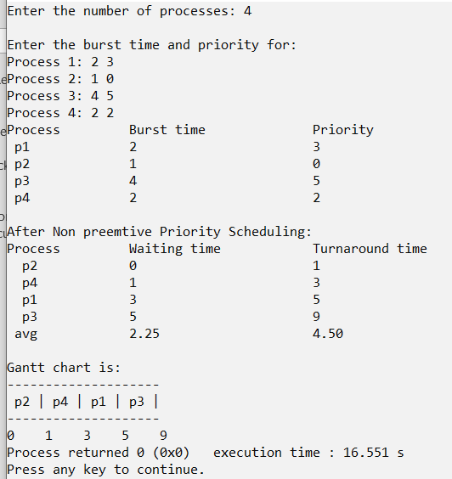

**4)First Come First Serve With Arrival**

#include<stdio.h>

///With Arrival First Come First Serve

///Adnan Ismail Shah Muzavor

#include<stdlib.h>

/// Sorting key will help in sorting

/// when we want to sort values based on some

/// some other aspect

typedef struct array

{

int b_time; ///burst_time

int a_time; ///arrival time

int s_key; ///sorting key eg priority

} Prc;

///To find average

float avg(int *arr,int n)

{

float avg=0.0;

int i=0;

for(i=0; i<n; i++) avg+=(float)arr[i];

return (avg/(float)n);

}

///To display the result

void display(int *order,int *wt,int *tt,int n)

{

int i;

printf("Process\t\tWaiting time\t\tTurnaround time\n");

for(i=0; i<n; i++)

{

printf(" p%d \t\t%d\t\t\t%d\n",order[i]+1,wt[i],tt[i]);

}

printf("avg \t\t%.2f\t\t\t%.2f\n",avg(wt,n),avg(tt,n));

}

void merge(int l,int m,int h,Prc p1[],int order[])

{

///id s_key is one use sort key else sort directly

int temp[h-l+1];

int temp2[h-l+1];

int new_order[h-l+1];

int i=l,j=m+1,k=0;

while(i<=m && j<=h)

{

if(p1[i].a_time<=p1[j].a_time)

{

temp[k]=p1[i].b_time;

temp2[k]=p1[i].a_time;

new_order[k]=order[i];

i++;

k++;

}

else

{

temp[k]=p1[j].b_time;

temp2[k]=p1[j].a_time;

new_order[k]=order[j];

j++;

k++;

}

}

///Add remaining elemnts

while(i<=m)

{

temp[k]=p1[i].b_time;

temp2[k]=p1[i].a_time;

new_order[k]=order[i];

k++;

i++;

}

///Add remaining elemnts

while(j<=h)

{

temp[k]=p1[j].b_time;

temp2[k]=p1[j].a_time;

new_order[k]=order[j];

k++;

j++;

}

///Modify original array

i=l,k=0;

while(i<=h)

{

p1[i].b_time=temp[k];

p1[i].a_time=temp2[k];

order[i]=new_order[k];

i++;

k++;

}

}

///sort p1 based on a_key i.e arrival time

void mergesort(int i,int j,Prc p1[],int order[])

{

if(i<j)

{

int m=(i+j)/2;

mergesort(i,m,p1,order);

mergesort(m+1,j,p1,order);

merge(i,m,j,p1,order);

}

}

///Display the input/sorted/processed input

void raw_display(int order[],Prc p1[],int n)

{

int i;

for(i=0; i<n; i++)

{

printf(" p%d \t\t%d\t\t\t%d\n",order[i]+1,p1[i].a_time,p1[i].b_time);

}

}

void FCFS_A(Prc p1[],int order[],int n)

{

int i,sum=0,gt_itr=0;

int*wt=(int*)malloc(sizeof(int)*n);

int*tt=(int*)malloc(sizeof(int)*n);

int*bb=(int*)malloc(sizeof(int)*n);

int*gt=(int*)malloc(sizeof(int)*n);

for(i=0; i<n; i++)

{

bb[i]=0;

gt[i]=0;

}

///Before doing anything for sort processes based on arrival time

///As process which arrived first will be served first

mergesort(0,n-1,p1,order);

///On this order run first come firts serve aogorithm

wt[0]=0; ///Initially waiting time is zero for first process in p1

gt[0]=p1[0].a_time; ///As we will be executing processes right from first process which min arrival time

///It's not necesssary that this arrival time will always be zero

sum=p1[0].a_time; ///AHence w eare adding up this time in sum as well!!

for( i=0; i<n; i++)

{

///Calculate waiting time

if(i>0)

{

/// for i=0, we already know waiting time is zero

/// otherwise it is burst time of prev process

sum=sum+p1[i-1].b_time; /// Burst time of ith process

wt[i]=(sum-p1[i].a_time);

///If process arrived much later while prev process was executing

if(p1[i].a_time>sum)

{

///Thr process doent has to wait

wt[i]=0;

bb[i]=100;

gt[gt_itr]=sum;

gt_itr++;

///Add to burst time and time of this blank slot

sum+=(p1[i].a_time-sum); //Add time taken by blank slot

}

gt[gt_itr]=sum;

}

///Calculate turnround time

tt[i]=p1[i].b_time+wt[i];

gt_itr++;

}

///Add burst time of last process

gt[gt_itr]=sum+p1[n-1].b_time;

gt_itr++;

printf("\n");

display(order,wt,tt,n);

ganttchart(order,gt,bb,n,gt_itr);

}

void ganttchart(int *order,int*gt,int* bb,int n,int n2)

{

int i;

printf("\nGantt chart is: \n");

for(i=0; i<n; i++)

{

if(bb[i]) printf("------");

printf("------");

}

printf("\n");

for(i=0; i<n; i++)

{

if(bb[i]==0) printf(" p%d |",order[i]+1);

else printf(" --| p%d |",order[i]+1);

}

printf("\n");

for(i=0; i<n; i++)

{

if(bb[i]) printf("------");

printf("------");

}

printf("\n");

for(i=0; i<n2; i++)

{

printf("%d ",gt[i]);

}

}

int main()

{

int n,i;

printf("Enter the number of processes: ");

scanf("%d",&n);

Prc *p1=(Prc*)malloc(sizeof(Prc)*n);

int *pr_order=(int*)malloc(sizeof(int)*n); ///For storing process order

for(i=0; i<n; i++) pr_order[i]=i;

printf("\nEnter the BURST time and ARRIVAL time for: \n");

for(i=0; i<n; i++)

{

printf("Process %d: ",i+1);

scanf("%d",&p1[i].b_time);

scanf("%d",&p1[i].a_time);

p1[i].s_key=-1;

}

printf("Process\t\tArrival time\t\tBurst time\n");

raw_display(pr_order,p1,n);

printf("Aftre Firts Come First Serve Schedulling: ");

FCFS_A(p1,pr_order,n);

return 0;

}

**Output:**

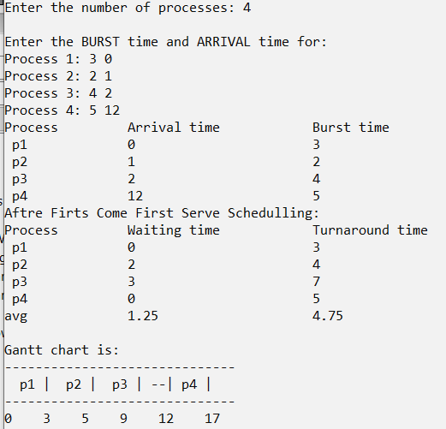

**5)Shortest Job First With Arrival**

#include<stdio.h>

///With Arrival Shortest job first

///Adnan Ismail Shah Muzavor

#include<stdlib.h>

/// Sorting key will help in sorting

/// when we want to sort values based on some

/// some other aspect

typedef struct array

{

int b_time; ///burst_time

int a_time; ///arrival time

int s_key; ///sorting key eg priority

} Prc;

///To find average

float avg(int *arr,int n)

{

float avg=0.0;

int i=0;

for(i=0; i<n; i++) avg+=(float)arr[i];

return (avg/(float)n);

}

///To display the result

void display(int *order,int *wt,int *tt,int n)

{

int i;

printf("Process\t\tWaiting time\t\tTurnaround time\n");

for(i=0; i<n; i++)

{

printf("p%d \t\t%d\t\t\t%d\n",order[i],wt[i],tt[i]);

}

printf("avg \t\t%f\t\t%.2f\n",avg(wt,n),avg(tt,n));

}

///Display the input/sorted/processed input

void raw_display(int order[],Prc p1[],int n)

{

int i;

for(i=0; i<n; i++)

{

printf(" p%d \t\t%d\t\t\t%d\n",order[i],p1[i].a_time,p1[i].b_time);

}

}

int decide_first(Prc p1[],int processed[],int n,int prev_burst_time)

{

///To keep track of process to be executed first

int first_p=-1,min_arrival_time=1000,min_burst_time=1000,i=0;

///Choose the first process to execute

if(prev_burst_time==-1)

{

for(i=0; i<n; i++)

{

///THe proces has arrival time lesser thn minimum arrival time so far

if(p1[i].a_time!=min_arrival_time && p1[i].a_time<min_arrival_time)

{

min_arrival_time=p1[i].a_time;

min_burst_time=p1[i].b_time;

first_p=i;

}

///If process has same minimum arrival time, thn check for burst time

///Consider the one with minimum burst time

else if(p1[i].a_time==min_arrival_time && p1[i].b_time<min_burst_time)

{

min_arrival_time=p1[i].a_time;

min_burst_time=p1[i].b_time;

first_p=i;

}

}

}

else

{

///No process executed therefore return process that will execute first

for(i=0; i<n; i++)

{

///If this process is not already included

if(!processed[i])

{

///If proces had arrived while prev was executing

if( p1[i].a_time<=prev_burst_time)

{

///If we have not selected any process as of now

if(first_p==-1)

{

first_p=i; ///Choose this process and thn look for other process;

min_burst_time=p1[i].b_time;

continue;

}

///If this process has lesser burst time thn proces we had arrived during this within same range

///i.e while prev process was executing

if(p1[i].b_time<min_burst_time)

{

min_burst_time=p1[i].b_time;

first_p=i;

}

}

}

}

}

if(first_p==-1)

{

int min_till_now=1000;

for(i=0; i<n; i++)

{

if(!processed[i])

{

int min_diff=p1[i].a_time-prev_burst_time;

if(min_diff<min_till_now)

{

first_p=i;

min_till_now=min_diff;

}

}

}

};

if(first_p==-1) return -1;

processed[first_p]=1;

return first_p;

}

int max(int a,int b)

{

if(a>b) return a;

return b;

}

void decide_order(Prc p1[],int order[],int n)

{

int soln[n]; ///Processes as per order of execution

Prc soln_p[n];

int new_order[n];

int k=0,i=0;

///To keep track of process to be executed first

int prev_process,max_b_time,min_arrival_time=1000,min_burst_time=1000;

int processed[n+1]; ///Non of pocesses are processed

for(i=0; i<n; i++) processed[i]=0;

///k<n i/e while all n processes are not scheduled

i=0;

while(i<n)

{

if(k==0)

{

soln[k]=decide_first(p1,processed,n,-1);

new_order[k]=soln[k];

prev_process=soln[k];

max_b_time=p1[soln[k]].a_time;

k++;

i++;

}

else

{

max_b_time+=p1[prev_process].b_time;

int p=decide_first(p1,processed,n,max_b_time);

if(p==-1)

{

i++;

continue; ///No iteration

}

new_order[k]=p;

soln[k]=p;

prev_process=soln[k];

k++;

i++;

}

}

///As per solution order design the arrange the processes

for(i=0; i<n; i++)

{

soln_p[i]=p1[soln[i]];

}

///Rearrange processes

for(i=0; i<n; i++)

{

p1[i]=soln_p[i];

order[i]=new_order[i];

}

}

void SJF_A(Prc p1[],int order[],int n)

{

int i,sum=0,gt_itr=0;

int*wt=(int*)malloc(sizeof(int)*n);

int*tt=(int*)malloc(sizeof(int)*n);

int*bb=(int*)malloc(sizeof(int)*n);

int*gt=(int*)malloc(sizeof(int)*n);

for(i=0; i<n; i++)

{

bb[i]=0;

gt[i]=0;

}

decide_order(p1,order,n);

///On this order run first come firts serve aogorithm

wt[0]=0; ///Initially waiting time is zero for first process in p1

gt[0]=p1[0].a_time; ///As we will be executing processes right from first process which min arrival time

///It's not necesssary that this arrival time will always be zero

sum=p1[0].a_time; ///AHence w eare adding up this time in sum as well!!

for( i=0; i<n; i++)

{

///Calculate waiting time

if(i>0)

{

/// for i=0, we already know waiting time is zero

/// otherwise it is burst time of prev process

sum=sum+p1[i-1].b_time; /// Burst time of ith process

wt[i]=(sum-p1[i].a_time);

///If process arrived much later while prev process was executing

if(p1[i].a_time>sum)

{

///Thr process doent has to wait

wt[i]=0;

bb[i]=100;

gt[gt_itr]=sum;

gt_itr++;

///Add to burst time and time of this blank slot

sum+=(p1[i].a_time-sum); //Add time taken by blank slot

}

gt[gt_itr]=sum;

}

///Calculate turnround time

tt[i]=p1[i].b_time+wt[i];

gt_itr++;

}

///Add burst time of last process

gt[gt_itr]=sum+p1[n-1].b_time;

gt_itr++;

printf("\n");

display(order,wt,tt,n);

ganttchart(order,gt,bb,n,gt_itr);

}

void ganttchart(int *order,int*gt,int* bb,int n,int n2)

{

int i;

printf("\nGantt chart is: \n");

for(i=0; i<n; i++)

{

if(bb[i]) printf("-----");

printf("-----");

}

printf("\n");

for(i=0; i<n; i++)

{

if(bb[i]==0) printf(" p%d |",order[i]+1);

else printf(" --| p%d |",order[i]+1);

}

printf("\n");

for(i=0; i<n; i++)

{

if(bb[i]) printf("-----");

printf("-----");

}

printf("\n");

for(i=0; i<n2; i++)

{

printf("%d ",gt[i]);

}

}

int main()

{

int n,i;

printf("Enter the number of processes: ");

scanf("%d",&n);

Prc *p1=(Prc*)malloc(sizeof(Prc)*n);

int *pr_order=(int*)malloc(sizeof(int)*n); ///For storing process order

for(i=0; i<n; i++) pr_order[i]=i;

printf("\nEnter the BURST time and ARRIVAL time for: \n");

for(i=0; i<n; i++)

{

printf("Process %d: ",i);

scanf("%d",&p1[i].b_time);

scanf("%d",&p1[i].a_time);

p1[i].s_key=-1;

}

printf("Process\t\tArrival time\t\tBurst time\n");

raw_display(pr_order,p1,n);

printf("\nAfter Shotrest Job First Schedulling:\n");

SJF_A(p1,pr_order,n);

return 0;

}

**Output:**

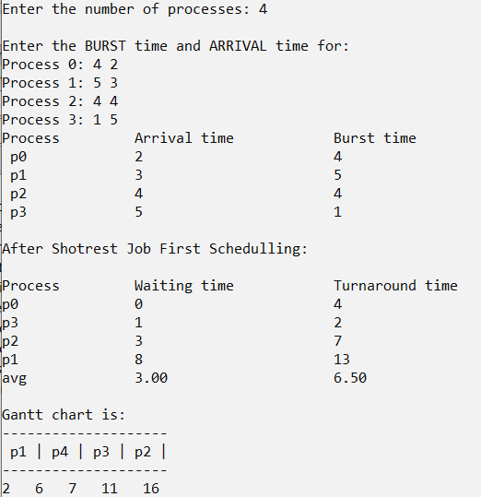

**6)Non preemtive priority With Arrival**

#include<stdio.h>

///With Arrival Non Pre-emtive priority

///Adnan Ismail Shah Muzavor

#include<stdlib.h>

/// Sorting key will help in sorting

/// when we want to sort values based on some

/// some other aspect

typedef struct array

{

int b_time; ///burst_time

int a_time; ///arrival time

int s_key; ///sorting key eg priority

} Prc;

///To find average

float avg(int *arr,int n)

{

float avg=0.0;

int i=0;

for(i=0; i<n; i++) avg+=(float)arr[i];

return (avg/(float)n);

}

///To display the result

void display(int *order,int *wt,int *tt,int n)

{

int i;

printf("Process\t\tWaiting time\t\tTurnaround time\n");

for(i=0; i<n; i++)

{

printf("p%d \t\t%d\t\t\t%d\n",order[i]+1,wt[i],tt[i]);

}

printf("avg \t\t%.2f\t\t\t%.2f\n",avg(wt,n),avg(tt,n));

}

///Display the input/sorted/processed input

void raw_display(int order[],Prc p1[],int n)

{

int i;

for(i=0; i<n; i++)

{

printf(" p%d \t\t%d\t\t\t%d\t\t\t%d\n",order[i]+1,p1[i].a_time,p1[i].b_time,p1[i].s_key);

}

}

int decide_first(Prc p1[],int processed[],int n,int prev_burst_time)

{

int first_p=-1,min_arrival_time=1000,highest_priority=1000,i=0,min_b_time=1000; ///this is used only when processes hv sme priority

///Choose the first process to execute

if(prev_burst_time==-1)

{

for(i=0; i<n; i++)

{

///THe proces has arrival time lesser thn minimum arrival time so far

if(p1[i].a_time!=min_arrival_time && p1[i].a_time<min_arrival_time)

{

min_arrival_time=p1[i].a_time;

highest_priority=p1[i].s_key;

first_p=i;

}

///If process has same minimum arrival time, thn check for burst time

///Consider the one with minimum burst time

else if(p1[i].a_time==min_arrival_time && p1[i].s_key<highest_priority)

{

min_arrival_time=p1[i].a_time;

highest_priority=p1[i].s_key;

first_p=i;

}

}

}

else

{

///No process executed therefore return process that will execute first

for(i=0; i<n; i++)

{

///If this process is not already included

if(!processed[i])

{

///If proces had arrived while prev was executing

if( p1[i].a_time<prev_burst_time)

{

///If we have not selected any process as of now

if(first_p==-1)

{

first_p=i; ///Choose this process and thn look for other process;

highest_priority=p1[i].s_key;

min_b_time=p1[i].b_time;

continue;

}

///If this process has lesser burst time thn proces we had arrived during this within same range

///i.e while prev process was executing

if(p1[i].s_key<highest_priority)

{

highest_priority=p1[i].s_key;

min_b_time=p1[i].b_time;

first_p=i;

}

else if(p1[i].s_key==highest_priority && p1[i].b_time<min_b_time){

min_b_time=p1[i].b_time;

first_p=i;

}

}

}

}

}

///No new process found to be arrive within given burst time

if(first_p==-1)

{

int min_till_now=1000;

highest_priority=10000;

for(i=0; i<n; i++)

{

if(!processed[i])

{

int min_diff=p1[i].a_time-prev_burst_time;

if(min_diff<min_till_now && p1[i].s_key<highest_priority )

{

first_p=i;

min_till_now=min_diff;

highest_priority=p1[i].s_key;

}

else if(min_diff==min_till_now && p1[i].s_key<highest_priority){

first_p=i;

highest_priority=p1[i].s_key;

}

}

}

};

if(first_p==-1) return -1;

processed[first_p]=1;

return first_p;

}

int max(int a,int b)

{

if(a>b) return a;

return b;

}

void decide_order(Prc p1[],int order[],int n)

{

int soln[n]; ///Processes as per order of execution

Prc soln_p[n];

int new_order[n];

int k=0,i=0;

///To keep track of process to be executed first

int prev_process,max_b_time,min_arrival_time=1000,min_burst_time=1000;

int processed[n+1]; ///Non of pocesses are processed

for(i=0; i<n; i++) processed[i]=0;

///k<n i/e while all n processes are not scheduled

i=0;

while(i<n)

{

if(k==0)

{

soln[k]=decide_first(p1,processed,n,-1);

new_order[k]=soln[k];

prev_process=soln[k];

max_b_time=p1[soln[k]].a_time;

k++;

i++;

}

else

{

max_b_time+=p1[prev_process].b_time;

int p=decide_first(p1,processed,n,max_b_time);

if(p==-1)

{

i++;

continue; ///No iteration

}

new_order[k]=p;

soln[k]=p;

prev_process=soln[k];

k++;

i++;

}

}

///As per solution order design the arrange the processes

for(i=0; i<n; i++)

{

soln_p[i]=p1[soln[i]];

}

///Rearrange processes

for(i=0; i<n; i++)

{

p1[i]=soln_p[i];

order[i]=new_order[i];

}

}

void NPP_A(Prc p1[],int order[],int n)

{

int i,sum=0,gt_itr=0;

int*wt=(int*)malloc(sizeof(int)*n);

int*tt=(int*)malloc(sizeof(int)*n);

int*bb=(int*)malloc(sizeof(int)*n);

int*gt=(int*)malloc(sizeof(int)*n);

for(i=0; i<n; i++)

{

bb[i]=0;

gt[i]=0;

}

decide_order(p1,order,n);

///On this order run first come firts serve aogorithm

wt[0]=0; ///Initially waiting time is zero for first process in p1

gt[0]=p1[0].a_time; ///As we will be executing processes right from first process which min arrival time

///It's not necesssary that this arrival time will always be zero

sum=p1[0].a_time; ///AHence w eare adding up this time in sum as well!!

for( i=0; i<n; i++)

{

///Calculate waiting time

if(i>0)

{

/// for i=0, we already know waiting time is zero

/// otherwise it is burst time of prev process

sum=sum+p1[i-1].b_time; /// Burst time of ith process

wt[i]=(sum-p1[i].a_time);

///If process arrived much later while prev process was executing

if(p1[i].a_time>sum)

{

///Thr process doent has to wait

wt[i]=0;

bb[i]=100;

gt[gt_itr]=sum;

gt_itr++;

///Add to burst time and time of this blank slot

sum+=(p1[i].a_time-sum); //Add time taken by blank slot

}

gt[gt_itr]=sum;

}

///Calculate turnround time

tt[i]=p1[i].b_time+wt[i];

gt_itr++;

}

///Add burst time of last process

gt[gt_itr]=sum+p1[n-1].b_time;

gt_itr++;

printf("\n");

display(order,wt,tt,n);

ganttchart(order,gt,bb,n,gt_itr);

}

void ganttchart(int *order,int*gt,int* bb,int n,int n2)

{

int i;

printf("\nGantt chart is: \n");

for(i=0; i<n; i++)

{

if(bb[i]) printf("-----");

printf("-----");

}

printf("\n");

for(i=0; i<n; i++)

{

if(bb[i]==0) printf(" p%d |",order[i]+1);

else printf(" --| p%d |",order[i]+1);

}

printf("\n");

for(i=0; i<n; i++)

{

if(bb[i]) printf("-----");

printf("-----");

}

printf("\n");

for(i=0; i<n2; i++)

{

printf("%d ",gt[i]);

}

}

int main()

{

int n,i;

printf("Enter the number of processes: ");

scanf("%d",&n);

Prc *p1=(Prc*)malloc(sizeof(Prc)*n);

int *pr_order=(int*)malloc(sizeof(int)*n); ///For storing process order

for(i=0; i<n; i++) pr_order[i]=i;

printf("\nEnter the BURST time,PRIORITY , ARRIVAL time for: \n");

for(i=0; i<n; i++)

{

printf("Process %d: ",i+1);

scanf("%d",&p1[i].b_time);

scanf("%d",&p1[i].s_key);

scanf("%d",&p1[i].a_time);

}

printf("Process\t\tArrival time\t\tBurst time\t\tPriority\n");

raw_display(pr_order,p1,n);

///FCFS_A(p1,pr_order,n);

NPP_A(p1,pr_order,n);

return 0;

}

**Output:**

